# Problem 1.1

FunctionLib.py

def reduce1(a = []):  
 prd = 1  
  
 for i in a:  
 prd = prd * int(i)  
  
 print ("Reduce = ", prd)

TestReduce.py

from FunctionLib import *  
  
numStr = input ("Enter a list of Comma Separated numbers ")  
numLst = numStr.split(",")  
  
reduce1(numLst)

Output

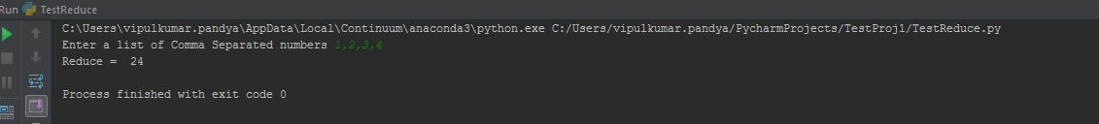

# Problem 1.2

Filter Class :

class filter1:  
  
 def __init__(self,func,iterobj = []):  
 self.func1 = func  
 self.iterobj1 = iterobj  
 self.start = self.iterobj1[0]  
 self.ctr=-1  
 #print(self.start)  
  
 def __iter__(self):  
 return self  
  
  
 def __next__(self):  
 if self.ctr < len(self.iterobj1)-1:  
 self.ctr +=1  
 self.module = __import__('FunctionLib')  
 self.func = getattr(self.module,self.func1)  
  
 while (self.func(self.iterobj1[self.ctr]) == False):  
 self.ctr+=1  
 if self.ctr == len(self.iterobj1)-1:  
 raise StopIteration  
  
 return self.iterobj1[self.ctr]  
 else:  
 raise StopIteration

Test Filter module :

from filterClass import *  
  
  
  
a = ['c','b','c','d','e']  
f = "function2"  
  
temp = filter1(f, a)  
  
for i in temp:  
 print(i)

Filter Functions (Functions Called by Filter1()) :

def function1(a):  
 if a=='b':  
 return True  
 else:  
 return False  
  
  
def function2(a):  
 if a == 'c':  
 return True  
 else:  
 return False  
  
  
def function3(a):  
 if a == 'd':  
 return True  
 else:  
 return False

Output

Test Filter module calls ‘function2’ which filters all ‘c’ and displays in output.

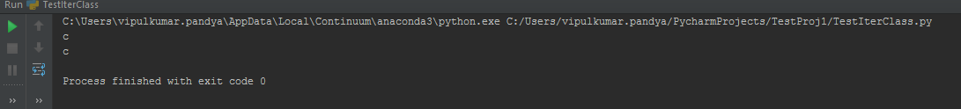

# Problem 2

List 1 :

a = input("Enter a string ")  
  
lst=[ i.upper() for i in a ]  
  
print (lst)

Output

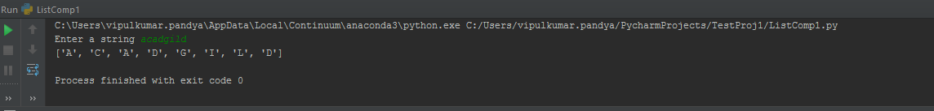

List 2 :

a = input("Enter a string ")  
  
lst=[ a[i-1]*int(k) for i in range(1,len(a)+1) for k in range(1,5)]  
  
print (lst)

Output

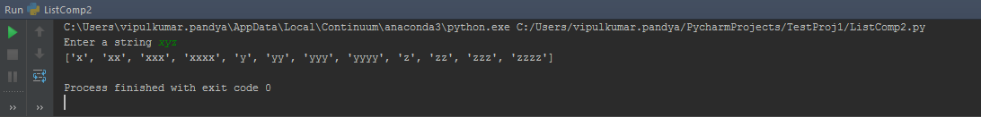

List3:

a = input("Enter a string ")  
  
lst=[ a[k-1]*int(i) for i in range(1,5) for k in range(1,len(a)+1)]  
  
print (lst)

Output

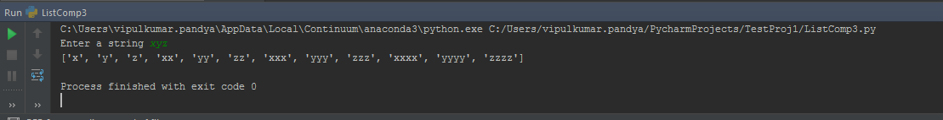

List 4

a = input("Enter a number ")  
  
lst=[[k] for i in range(2,int(a)) for k in range(i,i+3)]  
  
print (lst)

Output

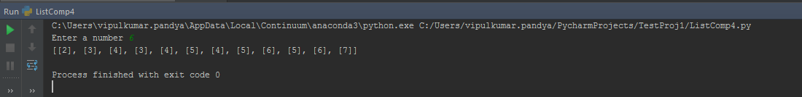

List 5

a = input("Enter a number ")  
  
temp=[]  
lst=[ [k,k+1,k+2,k+3] for k in range(2,int(a)) ]  
  
print (lst)

Output

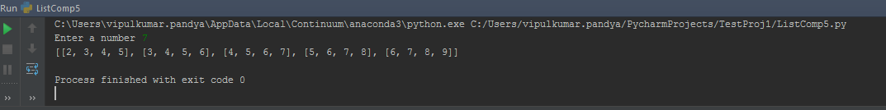

List6

a = input("Enter a number ")  
  
lst=[(k,i) for i in range(1,int(a)+1) for k in range(1,int(a)+1)]  
  
print (lst)

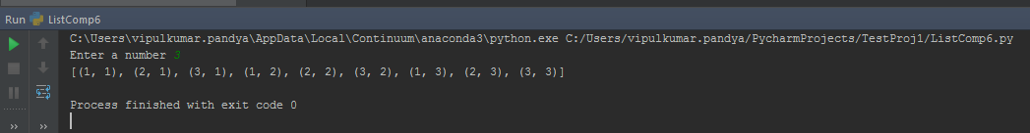

# Problem 3

def longestWord(a=[]):  
 index = 0  
 longLen = 0  
 ctr=0  
  
 for i in a:  
 if len(i) > longLen:  
 longLen = len(i)  
 index = ctr  
 ctr+=1  
 return a[index]  
  
  
a = input ("Enter a sentense :")  
lst = a.split(" ")  
print(longestWord(lst))

